 Final Year Project - UG
School of Computing Science and Engineering (SCOPE)
B.Tech. CSE/CPS/AL AND ML Capstone Project IN HOUSE
Weekly Status Report – Week_05- 26.12.2022 to 30.12.2022

Program: B.Tech. CSE/CPS/AI AND ML Batch: 2019-2023 Course Code: CSE1904

Register No.: 19BAI1032 Name of the Student: Tejasri B N Mobile No.:8610036563

Project Title: Bird Identification from Nature Sounds

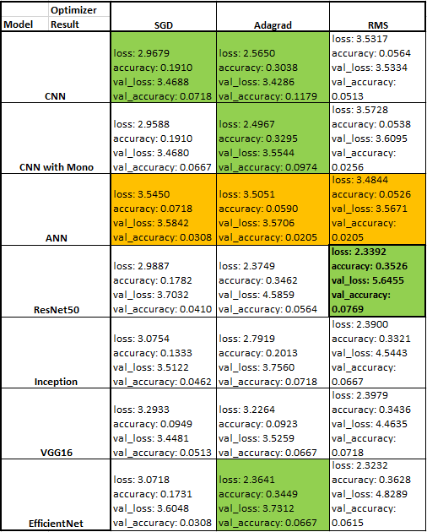
Technical Implementation Steps & Programming Tools :
Steps:
- ResNet50, Inception, VGG16, EfficientNet
- Various optimizers like Adagrad, RMS, SGD
Tools:
Jupyter Notebooks

05.12.2022 | ResNet50 Model
06.12.2022 | Inception Model
07.12.2022 | VGG16 Model
08.12.2022 | EfficientNet Model
09.12.2022 | Various parameter combination
Implementation | Patent / SCI / Scopus Indexed Journal Paper / Scopus Indexed Conference Paper/ Scopus  Indexed Book Chapter  _____________________________________________________________________________
Work Status | Excellent / Good / Satisfactory / Needs improve
Attendance Status | Regular / Irregular | CAM – Max. 5 Marks per week


Tejasri B N
30.12.23

Signature of the Student with date Name & Signature of the Guide with date

